**AllAccess**

| **Version No.** | **Date** | **Prepared By –** |
| --- | --- | --- |
| 1 | 25/09/2021 | Akansha Chourasia |
|  |  | Kirti Shekhar Pandey |
|  |  | Shubhi Singh |
|  |  | Utsav Pateriya |

**1. Introduction**

**Problem Definition:**

* Generic Problem

People need something just at the only place they can know about offers and discounts in their own city or nearby areas so that they can grab them easily. Sellers need a platform to advertise their product within their budget i.e. they can only advertise their product at low cost. Since big firms and brands spend huge amounts in advertising their products, what about sellers who sometimes have better product quality but only few know about that. As most people are shopaholics they always look forward to each opportunity.

In short, people need a platform that can do all the heavy lifting for them and provide them a simple and convenient way for sellers to advertise their product and buyers so that they can get knowledge of discounts and offers at one place. Also considering the well known fact we are giving them a platform to advertise products and get acknowledgement about the latest price.

* Purpose

Purpose is to design and develop a website which can connect many states , cities and areas. The website just needs registration of sellers and buyers so that we can acknowledge sellers with our schemes and he can post offers within his budget and we can acknowledge buyers of products of his interest . The idea of the project has come from the need of small sellers who have even better products than big brands but can only advertise their product and the need of sellers who do business from homes but have no source to advertise their product within their city.

**Scope**

The system is developed to provide a platform to sellers to advertise products within their budget and to buyers to see the latest price and product and do savings by purchasing products at less price compared to market price.

There are three basic actors:

1. **Administration**

Administration can add state , city and area and also remove it . Verify the seller. Generate list of sellers , registered buyers , state , city and area . Can view reports feedback regarding website, shop and product.

1. **Seller**

Seller can register himself. Can post , update , delete products and also view category and subcategory . Can ask questions or query from admin.

1. **Buyer**

Buyer can register himself and also view products and categories and add it to their wish list. Buyer can also give feedback regarding the website, shop and product.

**Objectives**

The objectives of this project are listed below:

* Fulfill all requirements.
* Implement a user friendly interface.
* Provide all products to the buyer.
* Complete the project by project due date.

**Project Goals**

This system will provide flexibility to small sellers doing business from home to advertise their product within their budget.

They can also advertise discounts and less prices sometimes.

Through this new seller can get a chance to sell products online.

**2. Scope of Change**

Some modifications are still left in All Access.

**3 List of impacted modules**

All the functional modules will be created from scratch.

**4 Design and Detailed technical updates**

**4.1 Process model**

**4.1.1 Use Case Diagram**

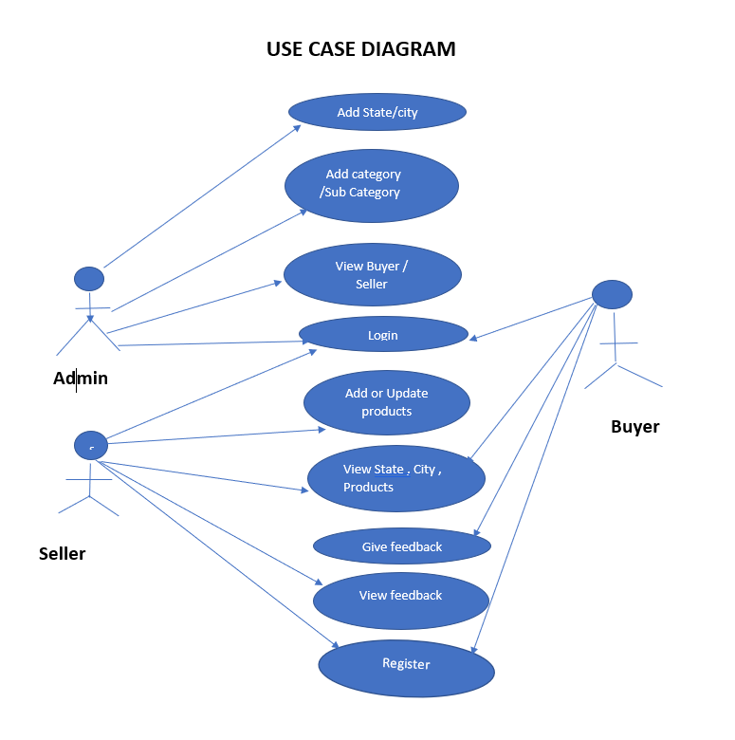

| | **Brief Description** | Buyer Registration | | --- | --- | | **Basic Flow** | This use case describes how a buyer registers into the system.  1.The buyer has to register himself into the system.  2.After the successful registration Buyer will get a Success message.  3.The following information is required during registration.  A. Name  B. Address  C. Mobile Number | | **Alternate Flow** | 1.The System will validate the information provided. | | **Pre-Conditions** | Users should have network access and a browser with the latest updates. | | **Post Conditions** | Success message should be shown. | | **Validation** | 1.Name is required.  2.The Email id should be valid.  3.Address should be valid. | |
| --- | --- | --- | --- | --- | --- | --- | --- | --- | --- | --- | --- | --- |

**Buyer Registration**

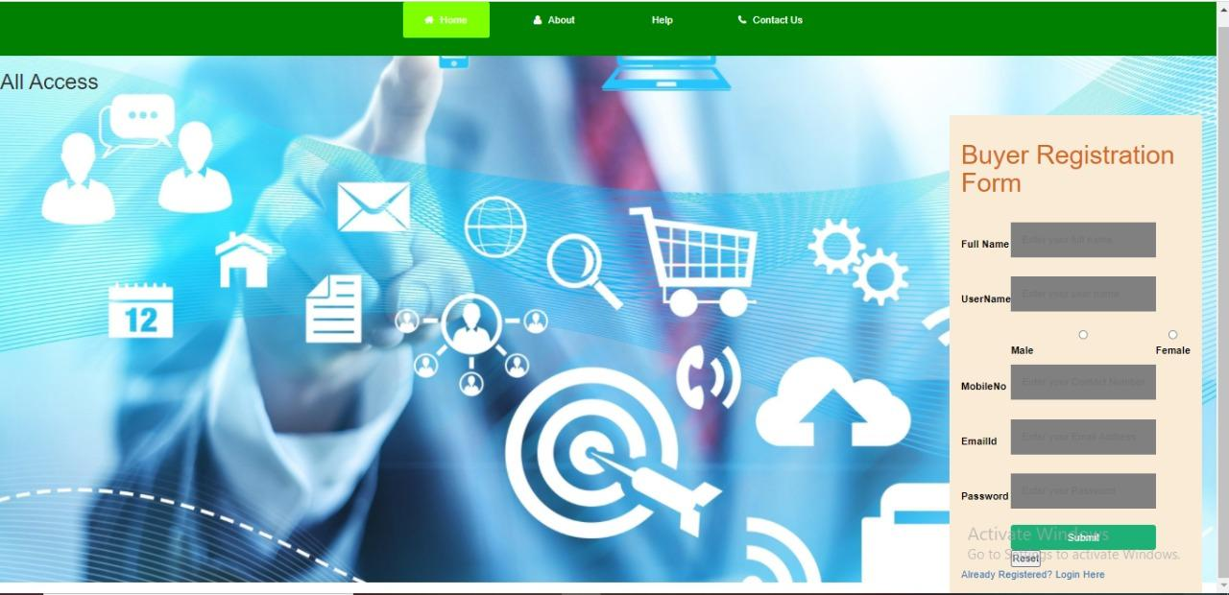

| | **Brief Description** | Seller Registration | | --- | --- | | **Basic Flow** | This use case describes how a buyer registers into the system.  1.The buyer has to register himself into the system.  2.After the successful registration Seller will get a Success message.  3.The following information is required during registration.  A. Name  B. Address  C. Mobile Number | | **Alternate Flow** | 1.The System will validate the information provided. | | **Pre-Conditions** | User should have network access and a browser with the latest updates. | | **Post Conditions** | Success message should be shown. | | **Validation** | 1.Name is required.  2.The Email id should be valid.  3.Address should be valid. | |
| --- | --- | --- | --- | --- | --- | --- | --- | --- | --- | --- | --- | --- |

**Seller Registration**

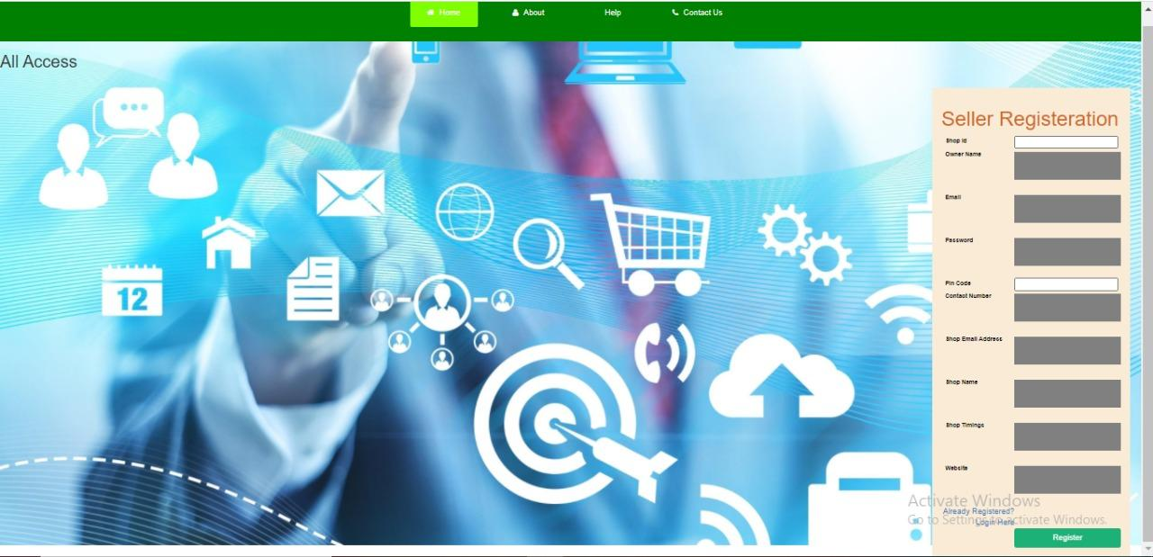

| Brief Description | **Admin, Seller, Buyer Login** |
| --- | --- |
| Basic Flow | This use case describes how a Seller or Buyer log-in in to the system   1. The Admin will be given credentials to the system. 2. After the successful login, buyer / Seller will be taken to the appropriate landing page. 3. The following information is required to login.  * Username * Password |
| Alternate Flow | 1. The system will validate the credentials provided. If credentials are invalid, the login form will be redirected again with an error message. |
| Validation | 1. Valid username 2. Valid password |
| Pre-Conditions | Seller / Buyer should have network access and Browser with latest updates. |
| Post-Conditions | Landing page has to be displayed. |

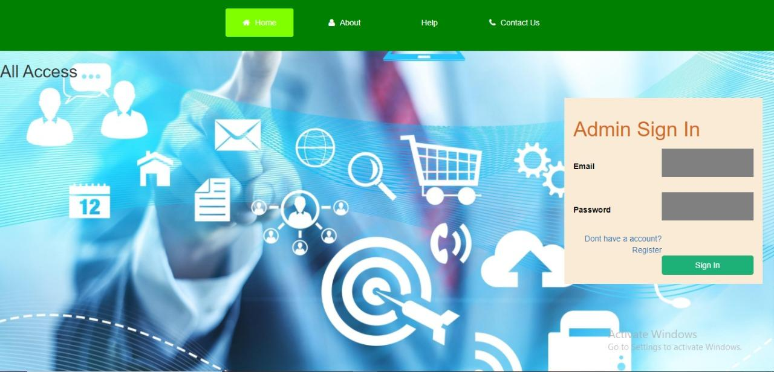

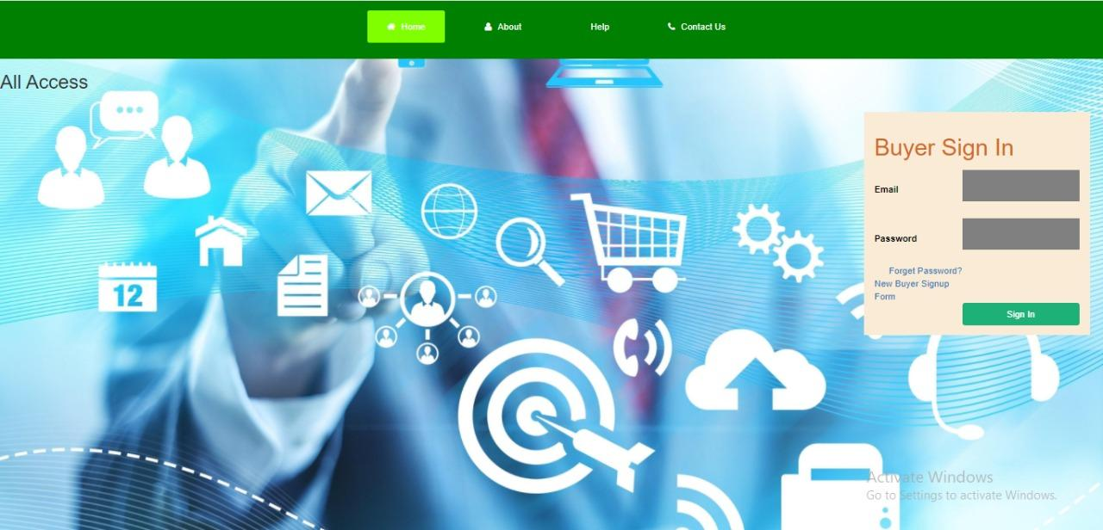

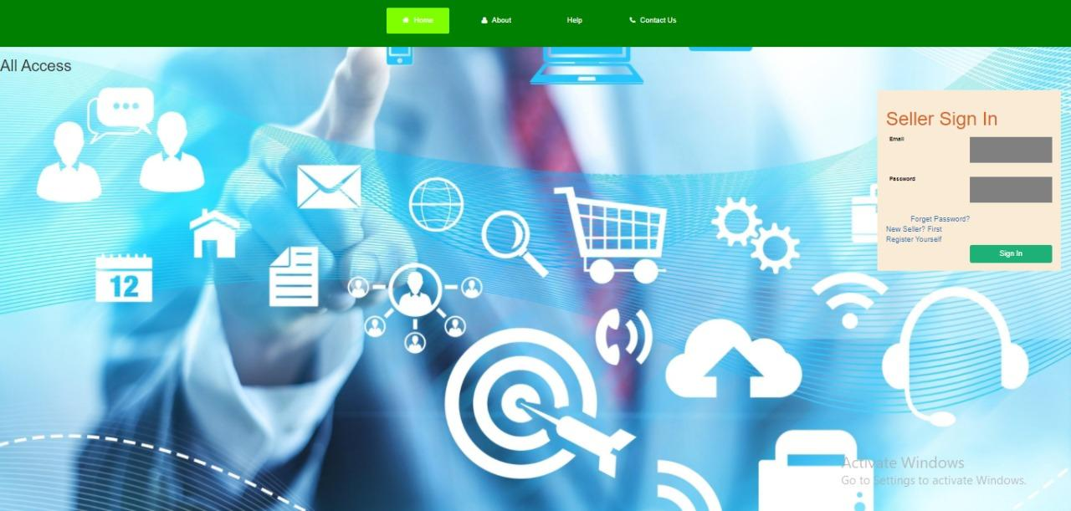

| Brief Description | **Dashboard** |
| --- | --- |
| Basic Flow | This use case describes how a admin would access the system   1. The Admin has to login into the system. 2. The Admin can do the following functionalities  * View all Buyers * View all Sellers * View all Feedbacks Given by Buyers * View All Enquiry Asked from Seller |
| Alternate Flow | Not Available |
| Validation | Not Available |
| Pre-Conditions | Buyer / Seller should have already logged into the system. |
| Post-Conditions | Success message should be shown. |

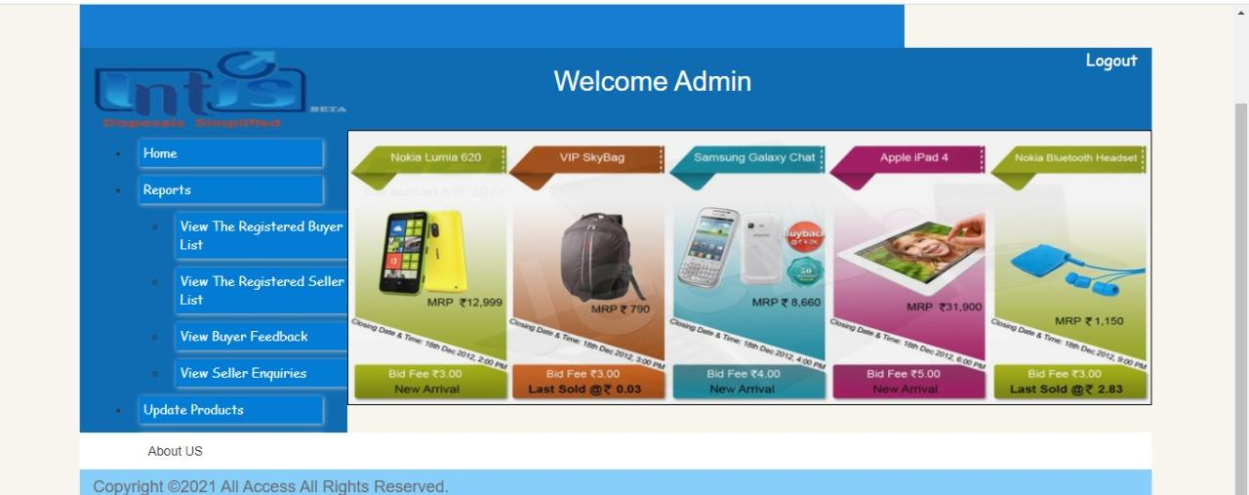

| Brief Description | **View Product (Buyer)** |
| --- | --- |
| Basic Flow | This use case describes how a buyer can view all the products added by Seller   1. The Buyer can access the Product directly from Buyer Homepage. 2. The following information would be displayed for every product.  * Product id * Product Name * Price * Manufacturing Date * Vat * Discount * Stock |
| Alternate Flow | Not Applicable |
| Validation | Not Applicable |
| Pre-Conditions | Not Applicable |
| Post-Conditions | Not Applicable |

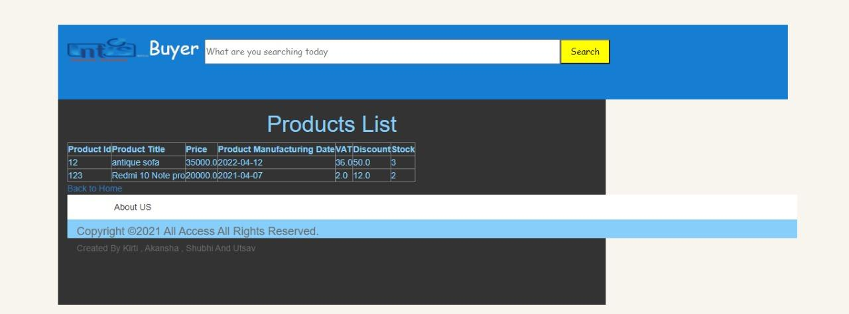

| Brief Description | **Add Product** |
| --- | --- |
| Basic Flow | This use case describes how a seller would add blog.  1.Seller should be logged in to add blog.  2.The following information is required to login.   * Product id * Product Name * Price * Manufacturing Date * Vat * Discount * Stock |
| Alternate Flow | System will validate, if entered product id is not unique then product will not successfully added. |
| Validation | Not Applicable |
| Pre-Conditions | Seller should have network access and Browser with latest updates. |
| Post-Conditions | Success message should be shown.(Product Added Successfully) |

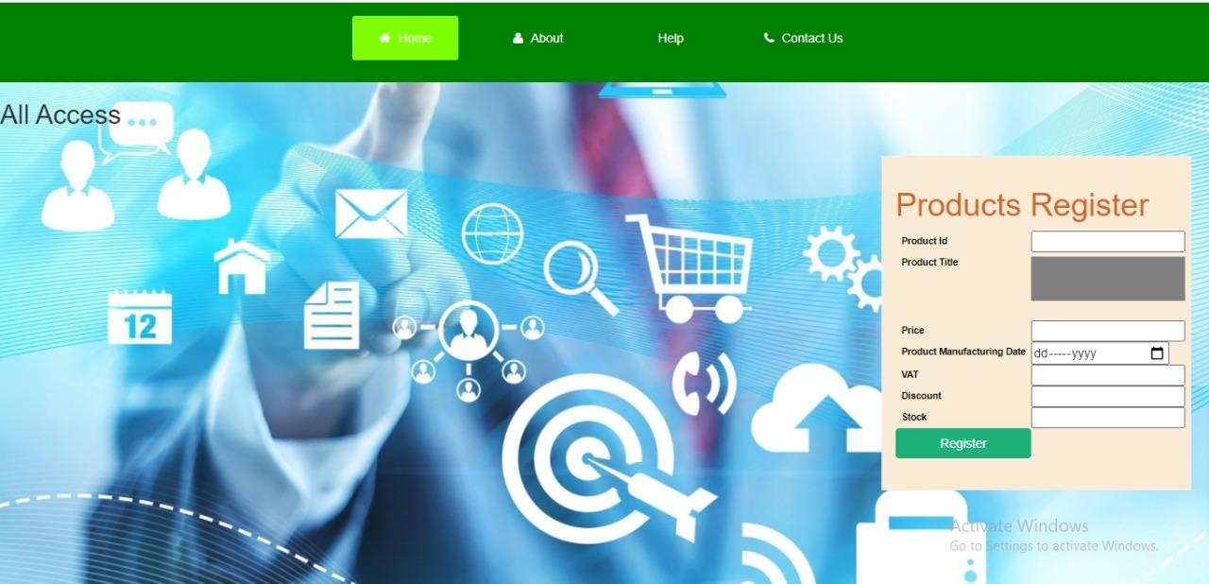

| Brief Description | **Enquiry Form** |
| --- | --- |
| Basic Flow | 1.This case describes how a Seller can raise a enquiry / request.  2.Open the enquiry page  3.Enter the information   * Name. * Email * Enquiry Type * Enquiry Message * Enquiry Date |
| Alternate Flow | The system will validate the information provided. If any invalid data is found, the input form will be redirected with an error message. |
| Validation | All the Fields are required. |
| Pre-Conditions | Seller should have network access and Browser with latest updates. |
| Post-Conditions | Success message should be shown. |

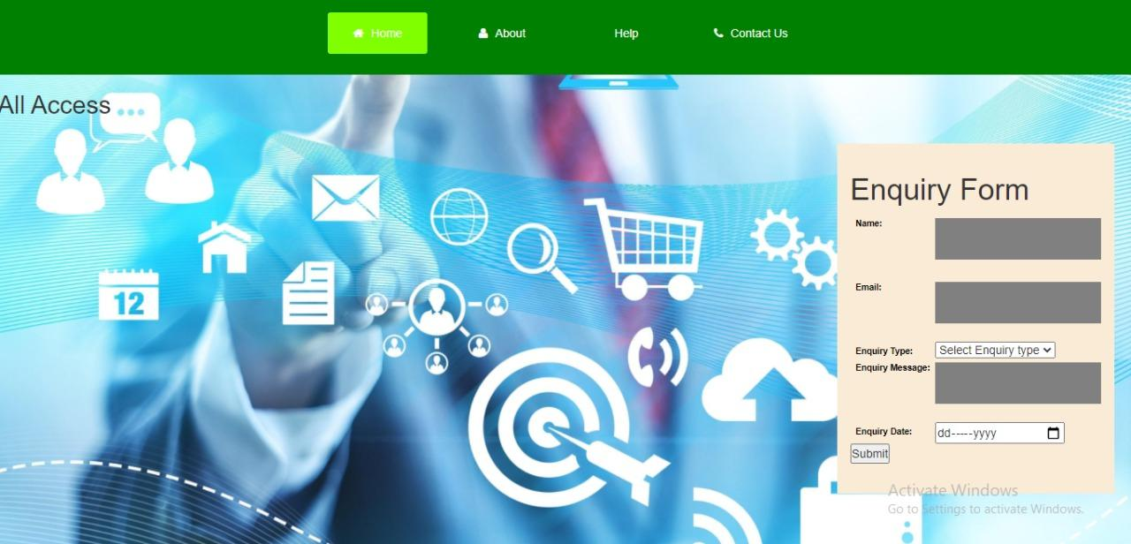

| Brief Description | **Feedback Form** |
| --- | --- |
| Basic Flow | 1.This case describes how a Buyer can provide feedback.  2.Open the feedback page  3.Enter the information   * Email * Rating * Feedback Message * Feedback Date |
| Alternate Flow | The system will validate the information provided. If any invalid data is found, the input form will be redirected with an error message. |
| Validation | All the Fields are required. |
| Pre-Conditions | Buyer should have network access and Browser with latest updates. |
| Post-Conditions | Success message should be shown. |

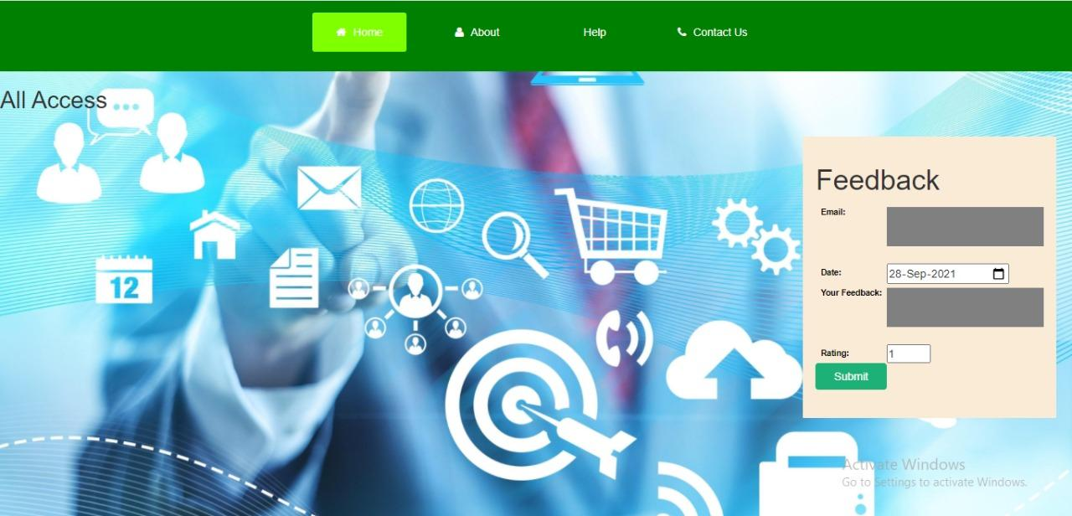

**4.1.2 Sequence Diagram**

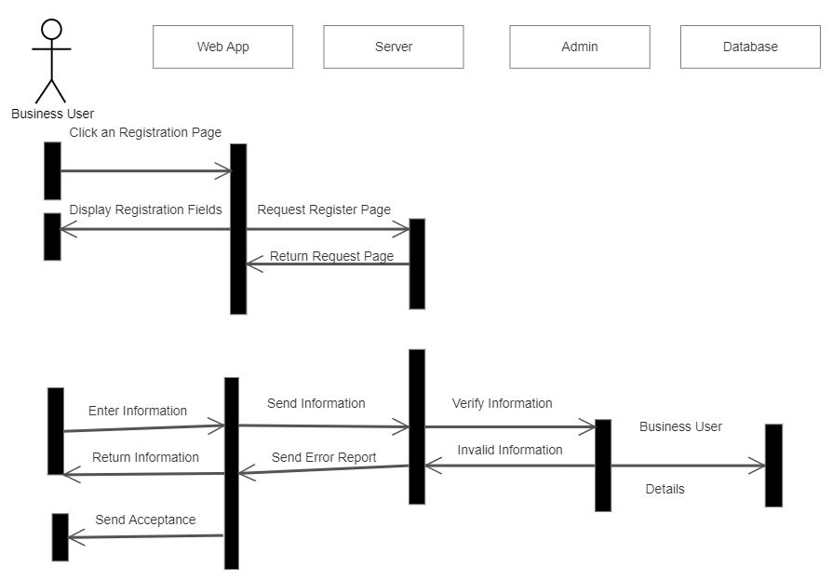



**5 Other Technical Changes**

**5.1 Functional Changes**

The functional requirements are requirements that are specified by the end-user. In this case the following are the functional requirements.

• The admin should be able to add a new category, subcategory, state and city.

• The admin should have the provision to view the buyer and seller list along with buyer feedback and seller enquiry list.

• The buyer should be able to view the product and category and subcategory.

• The buyer should be able to give the feedback which will be viewed by the admin.

• The seller should be able to view the enquiry message which will be viewed by the admin.

• The seller and buyer should be able to view their profile as well.

• The seller has the provision to view the sold products and also create a list of products.

**5.2 Non-functional Changes**

The Non-Functional Changes are changes that are not specifically mentioned by the customers but are few goal-points that will in the end give an efficient application. The Non-functional requirements are:

• Security

• Speed

• Efficiency.

• Minimum redundancy.

• Performance.

**6 References**

* **http://www.w3schools.com**
* **http://www.javatpoint.com**
* **http://www.tutorialspoint.com**
* **http://www.tektutorialshub.com**
* **http://www.angular.io**
* **http://www.geekforgeeks.com**
* **Http://www.coderanch.com**
* **Http://www.stackoverflow.com**